General Chemistry 2 Quarter 1 Week 4 (Module 6)

Millano, Rei Benedict L. 12-Laplace 9-6-22

**Monday**

Pre-Test:

1. 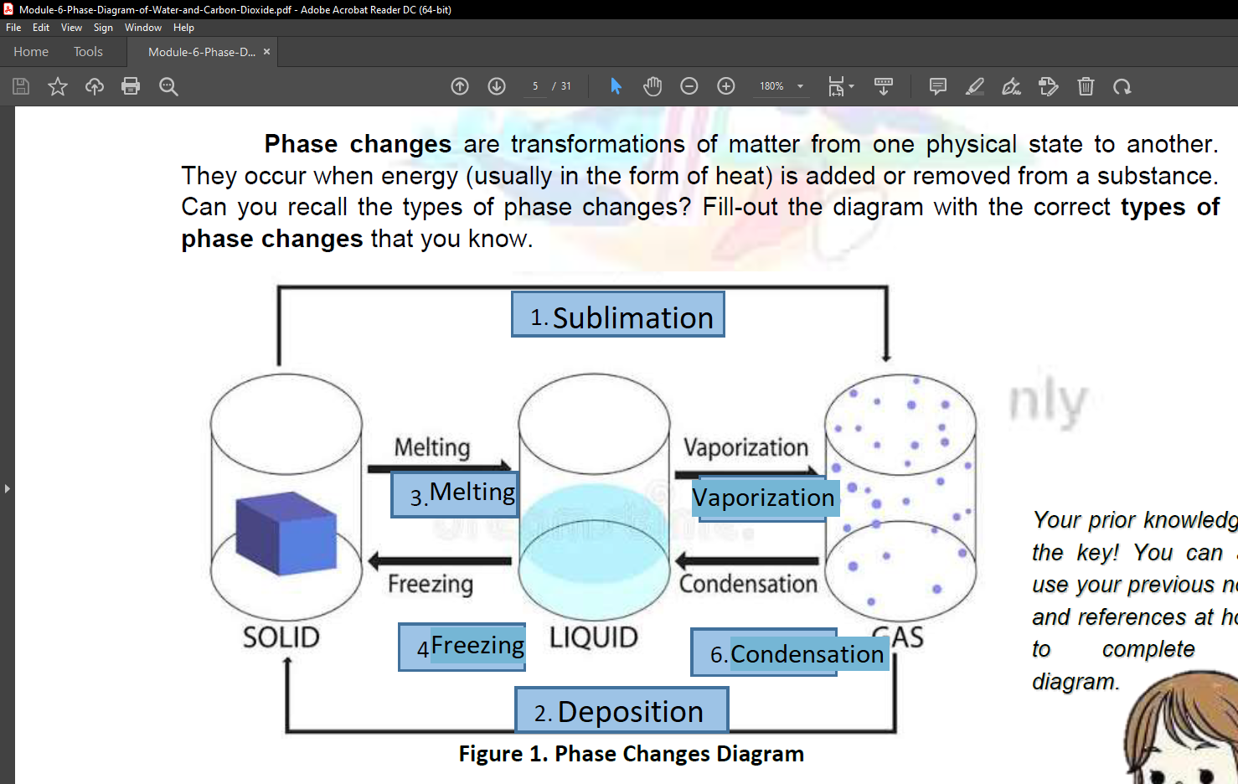A 2. C 3. A 4. A 5. C

Elicit:

1. Sublimation
2. Deposition
3. Melting
4. Freezing
5. Vaporization
6. Condensation

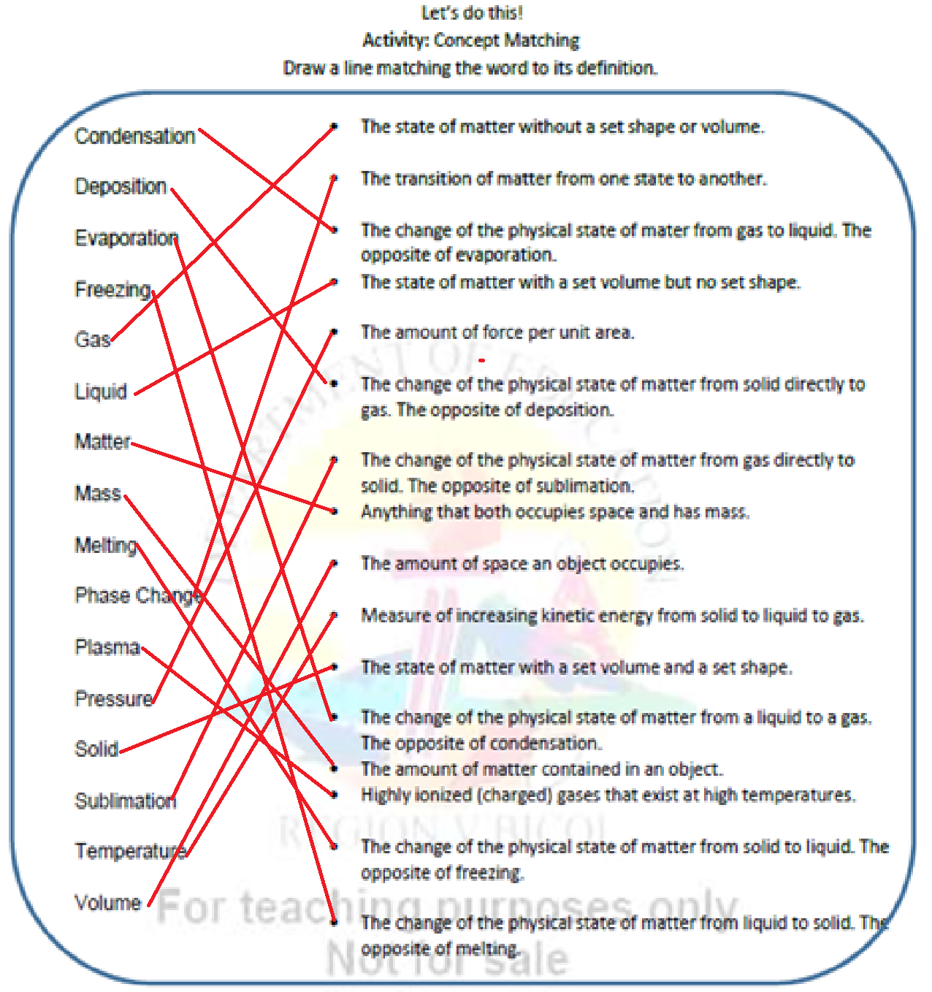Let’s Do This:

ENGAGE(Focus Questions) :

1. Because when C02 is frozen solid (Dry Ice) according to its phase diagram the needed earth atmospheric pressure is many times much higher along the regular temperature range making it succumb to sublimation.
2. 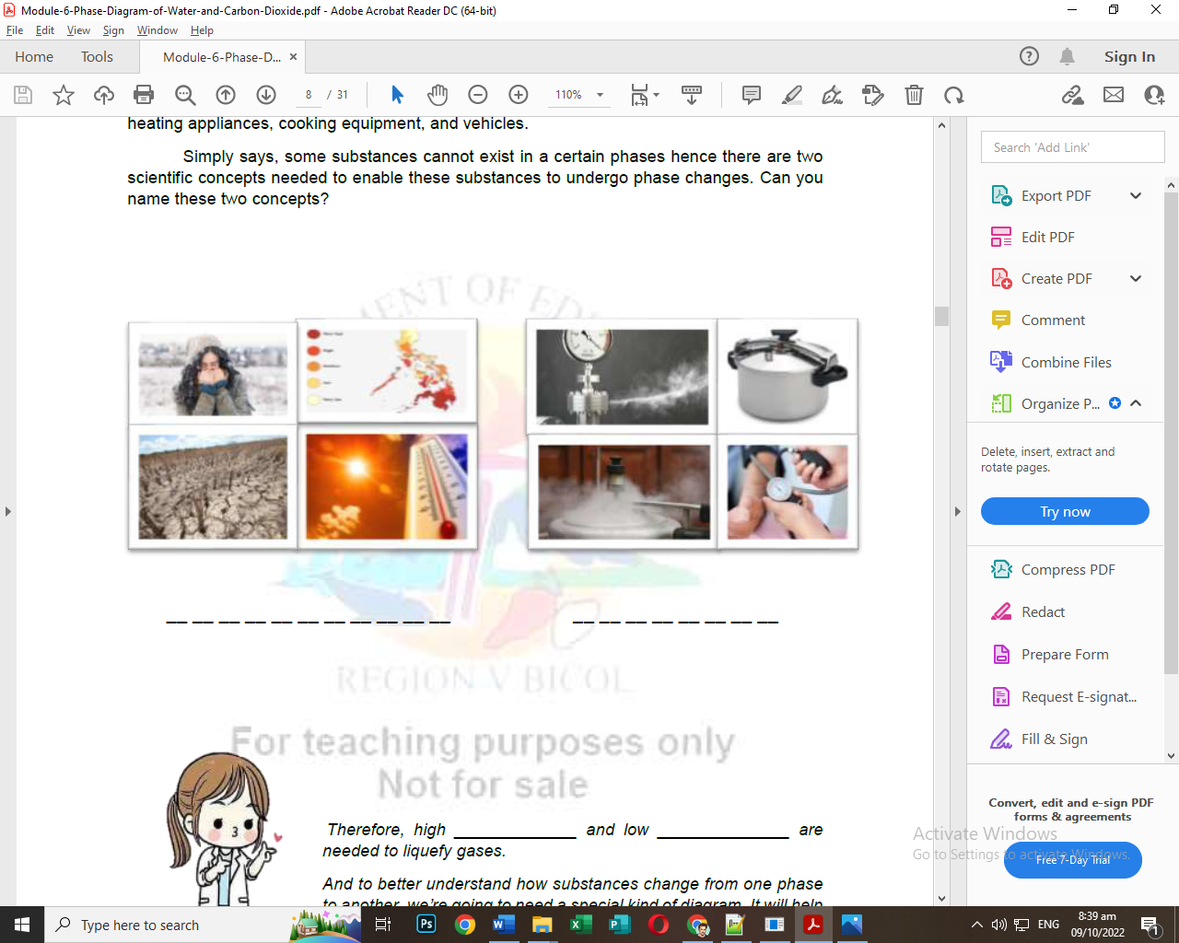Although pressure is factor of what phase of matter is and could be usually lowering the temperature turns it into solid when theoretically reaching absolute cold. For Propane it mostly needed below 2 times freezing point of water.

Explain:

1. a. 3 Phase Areas,

b. 3 Transition line

c. the triple and critical point

T E M P E R A T U R E P R E S S U R E

2. The solid phase in a phase diagram is usually located in the left side from top to bottom side of the diagram. While the vapor phase is at the bottom at borders with liquid and solid extending up to the critical point of the material. Then the liquid phase is at the center.

3. By using Crayons/Markers. The lines represent the border or transition point of phase changes from either liquid, solid or gas.

4. Typically the triple point is near the bottom left of the diagram and is the intersection of the three phases while the critical is far to right with a vertical dotted line. Also, it is generally label with T for triple and C for critical.

5. By choosing a specific point of the area of the phase of matter you want to achieve and with a specific pressure in mind you can look at what temperatures they are.

MIND MAP

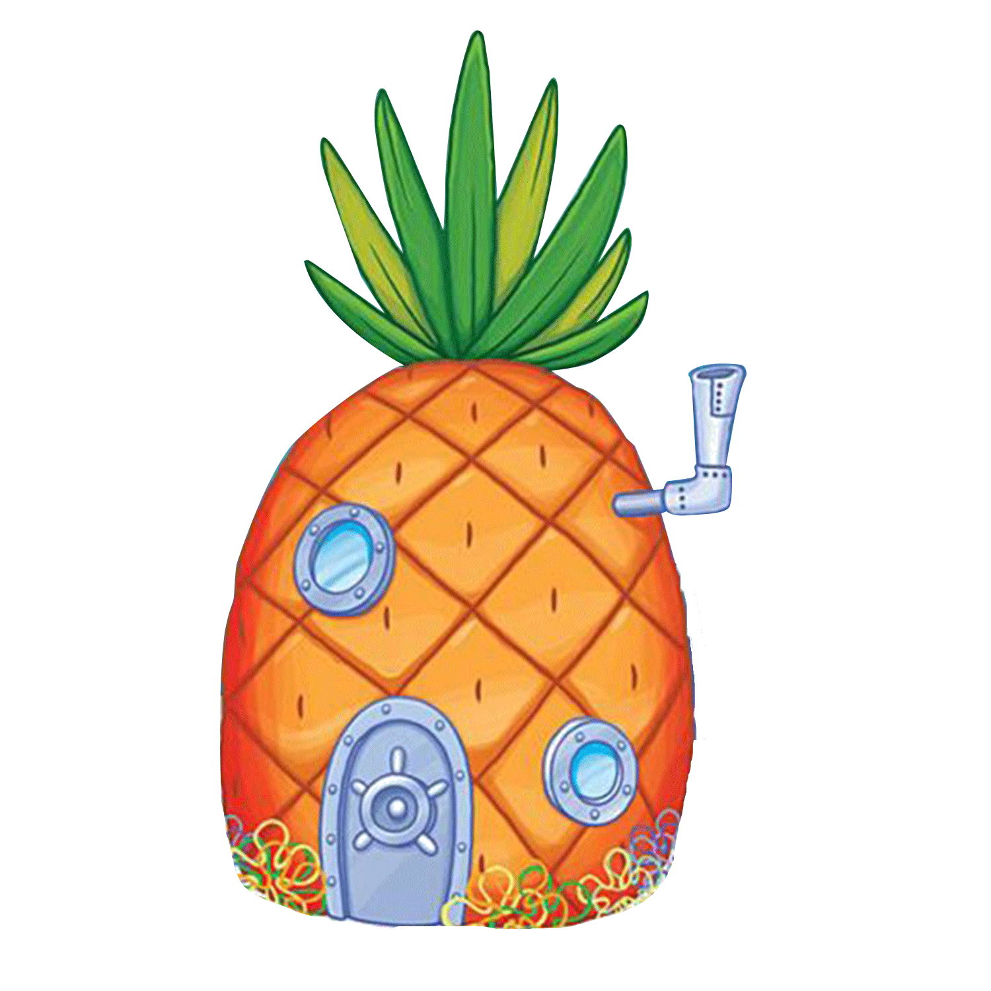

3 Phase Line

The important points

3 Phase Areas

PARTS OF A PHASE DIAGRAM

EVALUATE

1. liquid 2. Approximately 0.5 atm and 28 Celsius 3. Approximately 32 Celsius
2. Liquid and Vapor (Gas)

POST TEST

1. B 2. A 3. C 4. B 5. B

General Chemistry 2 Quarter 1 Week 4 (Module 7)

Millano, Rei Benedict L. 12-Laplace 9-9-22

**Tuesday**

PRETEST:

1. C 2. A 3. B 4. A 5. B

ELICIT:

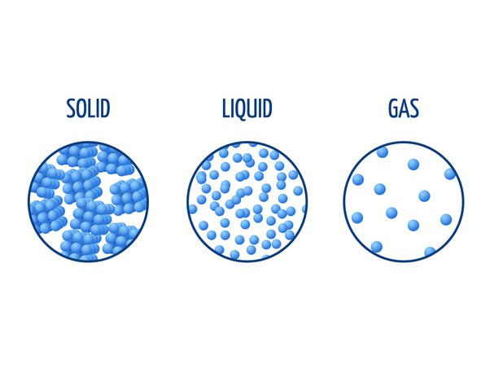 Step 1:

Step 5:

Q1. Solid has a defined shape and volume. Its particles forms closely to a lattice as it will naturally need to conform to.

Q2. Rigid particles cannot move/ slide past one another.

Q3. Liquid molecules assume the shape of the part of the container which it occupies. Liquids are close together with no regular arrangement.

Q4. Particles can move/ slide past one another. They vibrate, move about and slide past

each other.

Step 7

Q5. Gas molecules assume the shape and volume of its container. Particles are well

separated with no regular arrangement.

Q6. Gas vibrate and move freely at high speeds.

Step 8

Q7. We can transform a solid into a liquid by heating it up or increasing its temperature. As the solid becomes hotter and hotter, the molecules will start moving faster increasing its kinetic energy causing the solid ice to melt. Thus, the process is called melting.

Q8. We can transform a liquid into a gas by adding more heat. This causes the kinetic energy of the molecules to increase. The molecules will move quickly, flying out and bouncing, transforming into a gas. This process is called vaporization.

Step 10

Q9. Yes. But pulling heat out of the gas or decreasing heat of a substance. Kinetic energy will

decrease. The substance will be cooler. The gas will be a liquid. This is condensation.

Step 11

Q10. Yes. By decreasing the heat of the liquid. The kinetic energy will decrease. The

molecules will slow down. This is freezing.

**ENGAGE:** (Are there phase changes happening at your home? Below are examples of phase

changes. Can you cite other phase changes that you see inside your house? Draw/ list them

on the next page.)

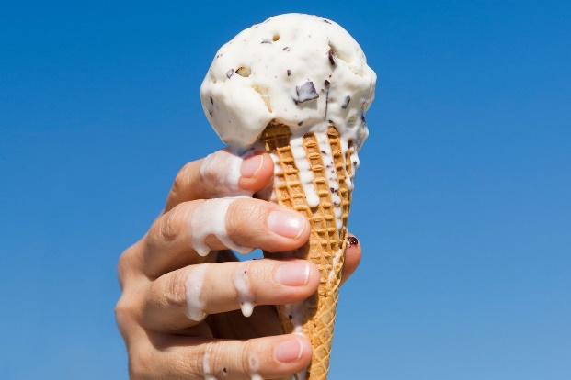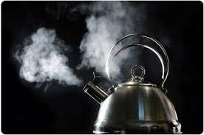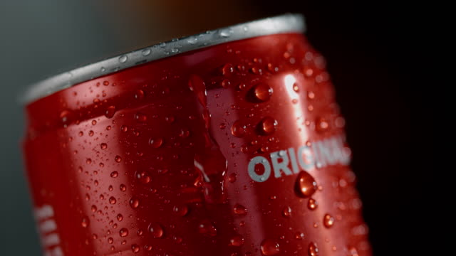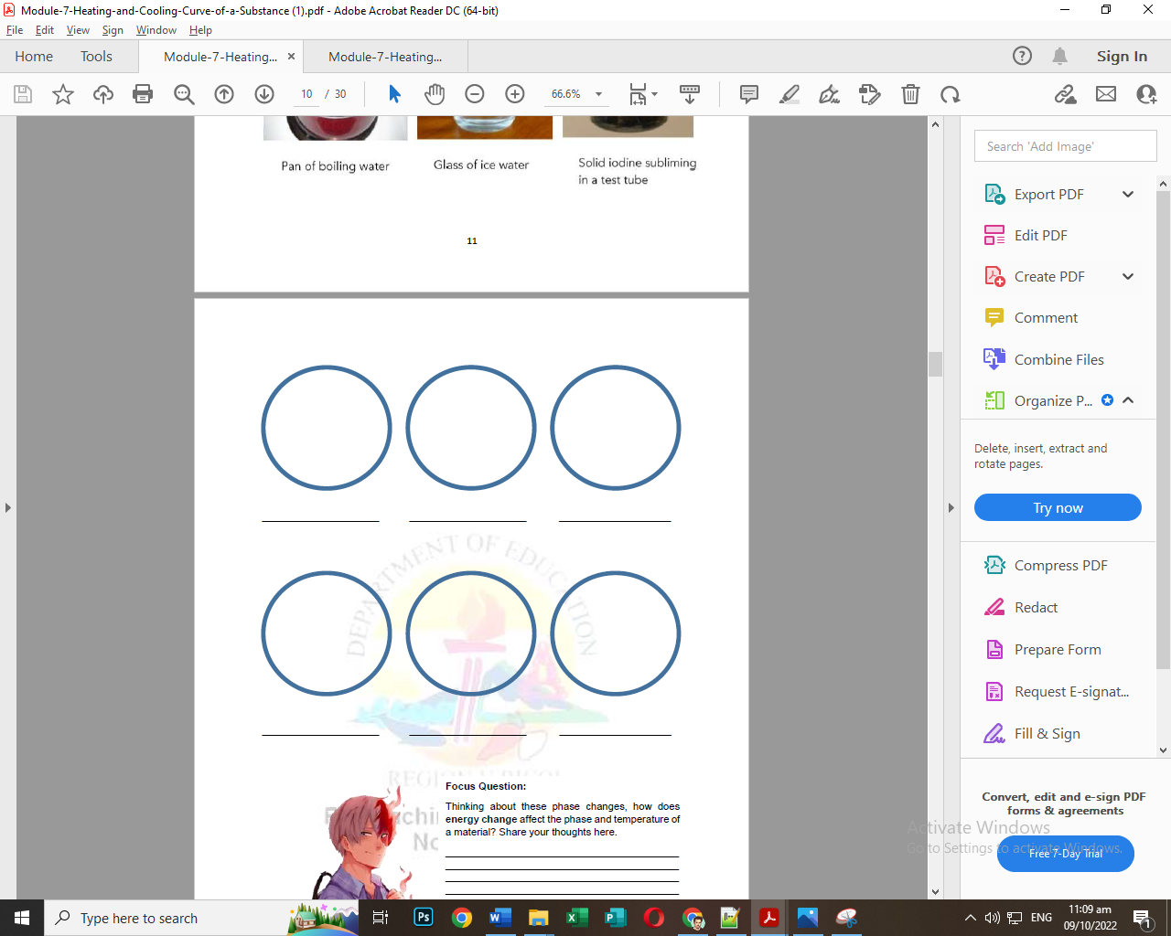

Moisture condensing on Water into steam from Ice Cream Melting coke can boiling kettle under the sun

Liquid drinks being frozen Dry Ice Sublimating Deposition of Nitrogen

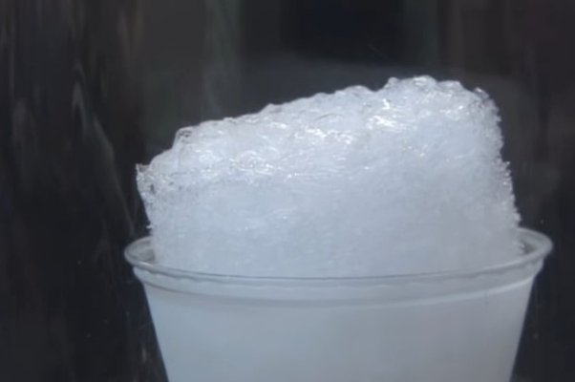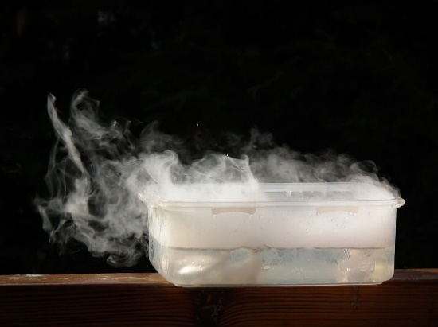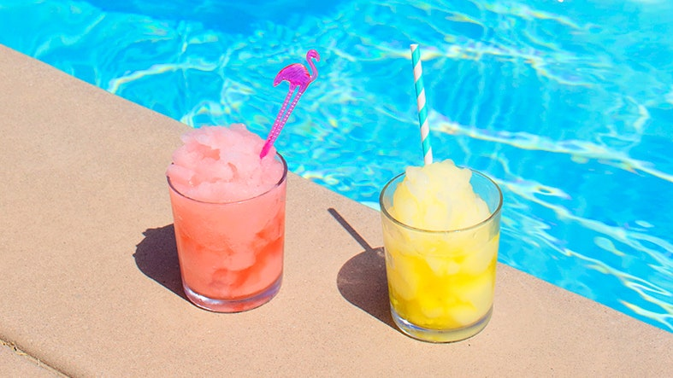

Focus Question: Energy change when energy is used from potential to other forms. It is said that there will always be some form energy loss through heat, radiation, sound and so on. Mainly, heat is a great byproduct of many reactions and changes in energy.

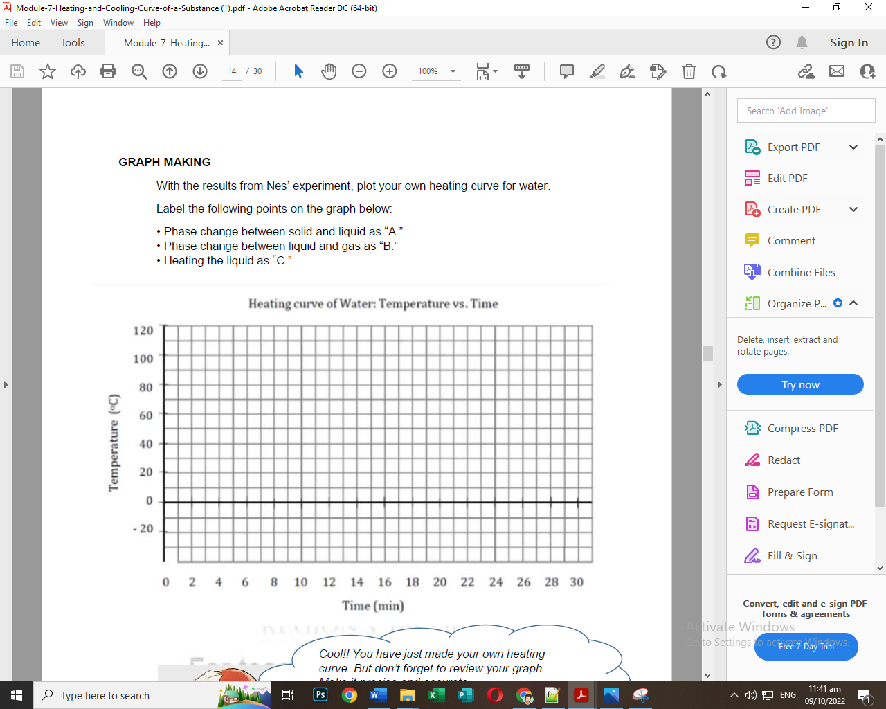**EXPLORE:**

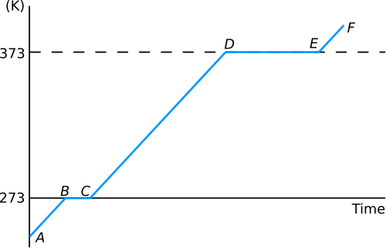

**EXPLAIN**

|  |  |
| --- | --- |
| **Questions:**  1. What is the chemistry term for a phase change when a solid becomes a liquid?  * Melting  2. What is the chemistry term for a phase change when a liquid becomes a gas?  * Vaporization  3. Describe the phase change that occurs during solidification (freezing).  * The phase shift in opposition to melting is freezing. This shift results from a substance's pressure and temperature changing.  4. Describe the phase change that occurs during condensation.  * The reverse of vaporization is a phase transition called condensation. A substance's pressure and temperature changes are what bring about this shift. | 5. What happens to the intermolecular forces of attraction inside an ice cube when it melts?  * Ice melts when heat energy causes the molecules to move faster, breaking the hydrogen bonds between molecules to form liquid water.  6. Why did the temperature of the liquid remain unchanged right around 100 °C  even though water was continuously heated?  * Because the overall temperature is not rising as the top layer takes away in small packets of steam and quickly condensing  7. Describe the difference between a phase change and a temperature change.  * The change of phase always occurs with a change of heat. However, the temperature does not change |

**EXTEND**

Graph Analysis:

1. What phase(s) exist at each of the numbered sections above?

P1. Gas

P2. Liquid/Gas

P3. Liquid

P4. Solid/Liquid

1. 60 Celsius
2. 20 Celsius
3. 2 and 4
4. 1
5. The intermolecular forces on section 1, was weak enough for the substance to turn into a gas
6. Heat is lost from point A to E over time
7. At point E the line ends and it should have the solid phase

EVALUATE

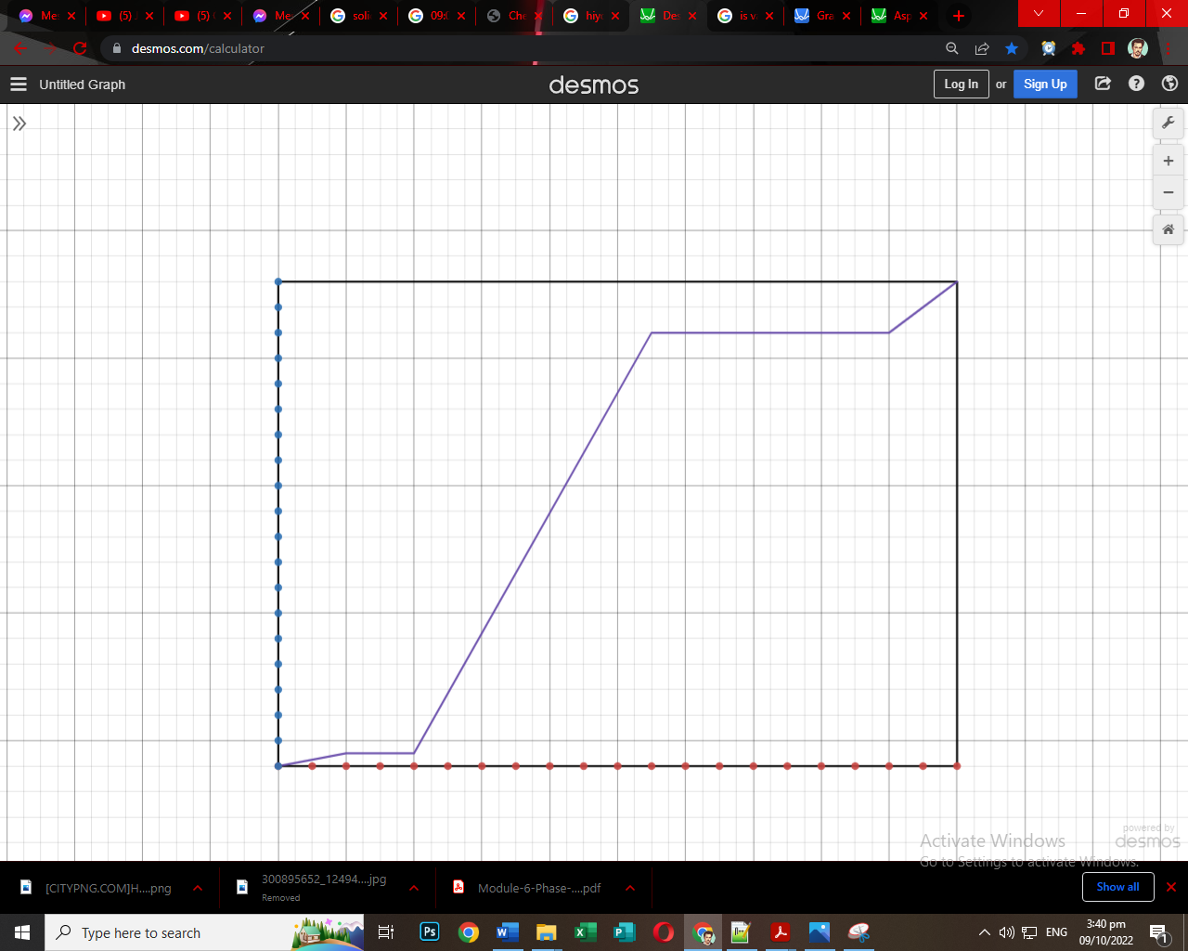 Heating Curve:

80

40

0

-40

-110

0 5 10 15 20